1. FISH & MACROINVERTEBRATES:
FISHING METHOD (Select all that apply): Seine: Traps: Rod & Reel: Electro-Shocking: Trawl: Kick Net: Eel Mop: DID NOT FISH: OYSTER CAGE___ Other: (Explain)

FISHING #1 TIME:_______________ | FISHING #2 TIME:_______________ | FISHING #3 TIME:_______________
FISHING #4 TIME:_______________ | FISHING #5 TIME:_______________ | FISHING #6 TIME:_______________
FISHING #7 TIME:_______________ | FISHING #8 TIME:_______________ | FISHING #9 TIME:_______________

FISH SPECIES TOTAL: # INDIVIDUALS: LARGEST SIZE SMALLEST SIZE
- _________________________________ ____________ ___________cm ___________cm
- _________________________________ ____________ ___________cm ___________cm
- _________________________________ ____________ ___________cm ___________cm
- _________________________________ ____________ ___________cm ___________cm
- _________________________________ ____________ ___________cm ___________cm
- _________________________________ ____________ ___________cm ___________cm
- _________________________________ ____________ ___________cm ___________cm
- _________________________________ ____________ ___________cm ___________cm
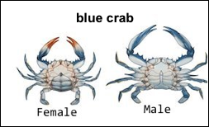
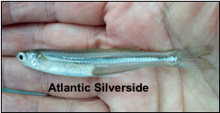
- _________________________________ ____________ ___________cm ___________cm
Identify crab species: Blue vs. Mud vs. Asian etc. If possible, include the sex of the crabs M/F.
Please take photos of the fish and send them to us for ID. This image of the Atlantic Silverside is the format to take fish pictures.
FULL BODY + HEAD TO THE LEFT
MACROINVERTEBRATE SPECIES TOTAL: # INDIVIDUALS: LARGEST /SMALLEST SIZE M / F
- _________________________________ ____________ ________cm ________cm M / F
- _________________________________ ____________ ________cm ________cm M / F
- _________________________________ ____________ ________cm ________cm M / F
- _________________________________ ____________ ________cm ________cm M / F
- _________________________________ ____________ ________cm ________cm M / F
- _________________________________ ____________ ________cm ________cm M / F
- _________________________________ ____________ ________cm ________cm M / F
- _________________________________ ____________ ________cm ________cm M / F
- _________________________________ ____________ ________cm ________cm M / F

CATCH PER UNIT EFFORT: CPUE= Catch of a seine event/ [Net Length (m) X Length of Pull (m)]
Time: ________ Catch Total: ________ Net Length (m): ________ Length of Pull: ________ Computed CPUE: ____________

